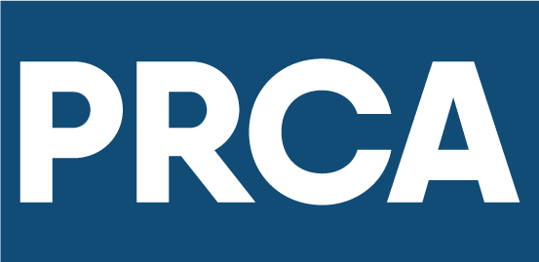
ACCESSIBLE COMMUNICATIONS GUIDELINES

FOREWORD
by Francis Ingham MPRCA
Director General, PRCA
Chief Executive, ICCO

As professional communicators, it is incumbent on us to make communications inclusive for people of all abilities so we can reach every member of society. Today, however, our industry falls short.
One in eight people globally have some form of disability. And every day they struggle to access content and communications from brands and organisations of all kinds.
They are excluded by default or by design.
It’s time we changed this.
Today we are publishing our first guidelines for Accessible Communications, designed to help every member of the PRCA and the industry beyond create more inclusive content and campaigns. The technology and tools to help us do this are readily available. The key priority is to update the way we work to adhere to best practices laid out in this document.
Current Global launched its Accessible by Design offer at the end of 2020, anchored by a commitment that every piece of communication it develops, curates or publishes on behalf of the firm and its clients will meet the highest accessibility standards. I want to recognise Current Global for being the first global agency to make such a commitment, and for partnering with the PRCA to develop these guidelines and help instigate change across the industry.
Together, we can make communications accessible for all.

EXECUTIVE SUMMARY

The PRCA is strongly committed to Diversity & Inclusion. These guidelines have been launched to further that priority commitment, with the goal of accelerating industry change to a point where all communications content and campaigns are accessible to people of all abilities.
This document is designed to help organisations and professionals gain a better understanding of the importance of accessible communications, and to equip them with practical tools, best practices and step-by-step processes to do so.
There are different forms of disabilities, but those most directly connected to and impacted by the accessibility of communications content and campaigns are: Visual, Hearing, Cognitive and Speech. These guidelines break down the different kinds of content and work typically produced by the communications industry, and the key considerations for making them accessible for people with disabilities in these four categories.
Lastly, this document includes some advice on embedding accessibility in the working practices of your communications function or organisation.
Note: These guidelines do not affect the responsibility of PRCA members to do their own due diligence to ensure compliance with statutory requirements on accessibility which may vary from country to country.

PRCA ACCESSIBLE COMMUNICATIONS MANIFESTO

The PRCA’s goal is to ensure the industry operates to the very highest accessibility standards so that communications are inclusive for people of all abilities.

What do we believe?
- No one should be excluded by default or design based on their ability.
- Inclusive communications are vital for a fairer, more equitable society.
- We have a responsibility to make the issue of inclusion more visible and to lead by example.

What do we want?
- For agency and in-house executives to lead from the top and help instigate industry change.
- To elevate accessibility as a board-level issue every brand and organisation needs to prioritise.
- For every professional to make a personal commitment to produce accessible communications.

How do we get there?
- Make accessibility a core requirement of every piece of communications content or campaign.
- Apply the tools and best practices in these guidelines every day in our work.
- Continue to learn and identify new opportunities to enhance the accessibility of communications.

SECTION 1 – THE IMPERATIVE FOR CHANGE

COMMUNICATING INCLUSIVELY IS BOTH MORALLY AND COMMERCIALLY THE RIGHT THING

Every day content is published that’s inaccessible to many. Campaigns are launched that have not been designed to be inclusive of people of all abilities.
But it doesn’t have to be this way.
According to the World Health Organization, over a billion people (one in eight of the world’s population) have some form of disability. With an ageing population, more than 2 billion people will need at least one assistive communication, memory or hearing aid in the next 10 years. In the UK, circa 20% of the population will experience communication difficulty at some point in their lives.
That’s a significant audience to exclude by default or by design.
An audience which collectively has a buying power of $8 trillion globally, according to Quartz.
The more we explore this topic, the more we learn of people who are impacted by it. We want our members to be at the forefront of solving this issue, recognising that if agencies and in-house teams act now, together we can make communications accessible to all people.
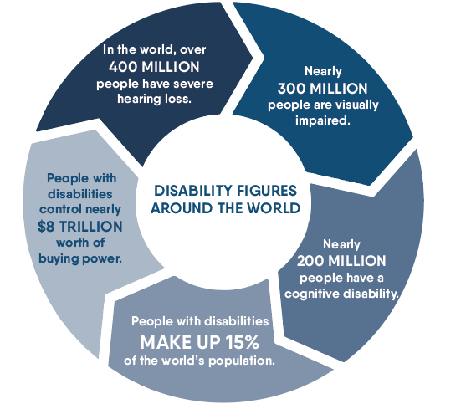

Disability in numbers
- On average, workers with disabilities earn less than workers without disabilities and are often denied access to education, technologies and social protection, among other essentials.
- Research suggests that companies will access a new talent pool of more than 10.7 million people if they embrace disability inclusion.
- Globally, more than 1 billion people need one or more assistive products, with only one in 10 having access to them.

A SYMBOL FOR CHANGE

In 2020, the PRCA helped launch a new disability symbol designed to make life easier for millions of people in the UK. The Communication Access Symbol (pictured below), with underpinning training and standards, was created for businesses, organisations and consumers by the Royal College of Speech and Language Therapists (RCSLT) in partnership with the Stroke Association, Headway, MND Association, Disability Rights UK, Business Disability Forum, Communication Matters, The Makaton Charity, and the National Network of Parent Carer Forums. The partnership is known as Communication Access UK. With the arrival of the symbol, businesses and organisations across the entire UK can now embrace the cause of accessible communication. Those who take free online training on accessible face-to-face, telephone and online customer service will earn the right to display the symbol - demonstrating they have all their customers’ needs close at heart.
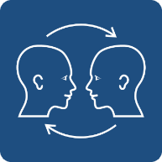

UNDERSTANDING THE LIVED EXPERIENCE OF CONSUMING MEDIA AND CONTENT

A 2021 study of more than 800 people with disabilities in the US and UK explored their lived experience with media and content. Commissioned by Current Global, the research revealed that the majority struggle with accessibility. Even those who have access to and use assistive technology encounter significant problems. Looking at social media specifically, people of all disabilities (visual 22%, hearing 17%, speech 27% and cognitive 23%) reported a struggle with accessing the content.
For many, they have ‘normalised’ their consistently poor experiences, leading to low expectations of brands and the content they produce. Emotionally, this takes a toll.
But when content and communications are accessible, the response is overwhelmingly positive, leading to a significant rise in brand preference, purchase intent and peer recommendations.
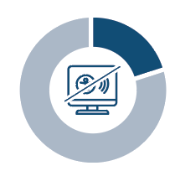 | A fifth of people surveyed said that social media platforms are very difficult to access and consume content on, making it the most problematic media channel.
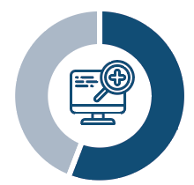 | 56% of the overall audience needs assistive tools, but they don’t have access to them, with many saying they are too expensive or inconvenient to set up.
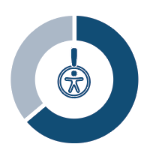 | 64% of those that use an assistive tool have reported having problems consuming content, with 30% of those respondents saying they have problems because of the content itself – pointing directly to where brands have an opportunity to help.
Inaccessible communications lead to a range of emotions:
- 38% feel frustrated
- 31% feel disappointed
- 27% feel ignored
- 21% feel unhappy
- 17% feel isolated
An overwhelming 81% have negative emotions towards brands when communications are not accessible,
with feelings of being disconnected, less excited, or that the brand lacks positive qualities or is unreliable.
When brands are accessible, they reap a host of benefits and spark positive emotions including feelings of:
- satisfaction (49%)
- support (45%)
- happiness (41%)
- inclusion (36%)
- relieved (28%)

SECTION 2 – HOW COMMUNICATORS CAN MAKE A DIFFERENCE

DISABILITIES AND THE IMPLICATIONS FOR ACCESSIBLE COMMUNICATIONS

Disabilities come in many forms, both visible and unseen, and fall within three broad categories:
- People with permanent disabilities.
- People with temporary impairments, e.g., broken arm.
- People managing situational requirements, e.g., working hands-free and eyes-free while driving.
We believe producing accessible communications within our industry should focus on people with permanent disabilities, which means working to the highest accessibility standards – that also encompass the needs of those with temporary impairments and situational requirements. The chart below shows the types of permanent disabilities and how they are most often manifested.
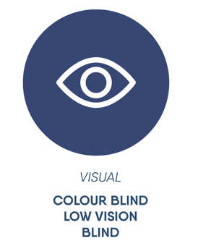 | 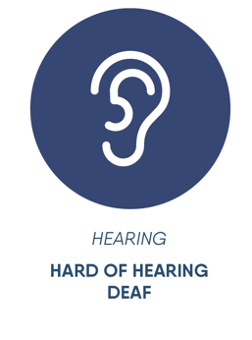 | 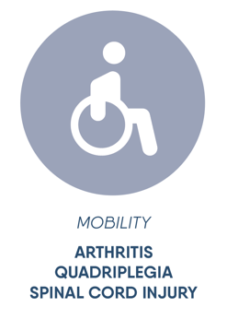
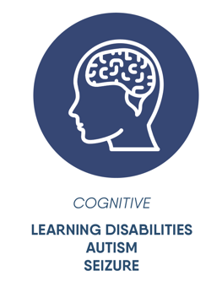 | 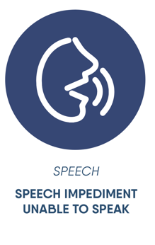 | 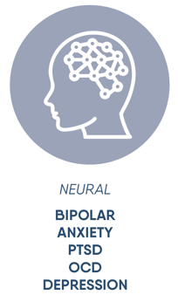

The disabilities that are most directly connected to and impacted by the accessibility of communications content and campaigns are the four highlighted: Visual, Hearing, Cognitive, and Speech. Mobility and Neural disabilities fall within the sphere of permanent disabilities too; however, they do not pose the same kind of consideration with regards to accessibility and consumption of the typical communications output our industry produces daily.
By ensuring that everything developed, curated or published within the remit of a communications campaign is made more accessible to people with visual, hearing, cognitive and speech disabilities, we will create more inclusive work that engages widest possible audiences.

WHAT THESE GUIDELINES COVER

We believe that communications content should be designed from concept to delivery to be inclusive of people of all abilities. For the purposes of these guidelines, we’ve defined ‘communications’ along the spectrum of services most commonly delivered by PR agencies and the work undertaken by in-house teams across earned, owned and social channels.
We have not explored related services such as website or app development. The World Wide Web Consortium (W3C) develops international Web standards for HTML, CSS, and more which web developers will be familiar with. All W3C standards are reviewed for accessibility support by the Accessible Platform Architectures (APA) Working Group. To find out more about accessibility implications in this context, please visit the W3C website.
Similarly, we do not address other areas of accessibility that may be important to a firm’s or client’s business such as accessible product design, which falls outside the typical remit of the communications function.
For additional guidance on handling practical issues associated with disability, please refer to the “Accommodating Disability” section of the PRCA Diversity & Inclusion guidelines.

SECTION 3 – DEVELOPING ACCESSIBLE CONTENT AND CAMPAIGNS

TYPES OF CONTENT
In our guidelines we have focused on the most common types of communications content, and the following pages document the tools to use and the steps you should follow to apply best practice and ensure the greatest degree of accessibility. Types of content we will address include:
- Visual content
- Text and written copy
- Social media content
- Influencer content
We’ve also included a special note on PDFs (typically a challenging document format with regards to accessibility) and on events.
Remember: These guidelines apply as much to the content you are paid to produce for your clients (as an agency) or your company (as an in-house team) as it does to the collateral you produce internally, such as branding, employee comms and web content, for example.

VISUAL CONTENT

VIDEO AND ANIMATED GRAPHICS
For all videos and animated graphics, you should:
- Always include a transcript, closed captions and audio descriptions.
- Provide the option of switching captions on or off while watching a video.
- Ensure strong contrast between text and background so people with low vision can see and use the content; ideally use dark text on a white or off-white background or reverse it and use white text on a dark background.
- Enable the Stop/Pause feature when a video plays automatically for more than 5 seconds.
- Avoid graphics shifting significantly and at different rates than text or other elements.
- Do not use flashing lights.
- Host content in an accessible player, such as Vimeo and ONE player, that supports accessibility features like closed captions, audio-description, various contrast themes, etc.
- If shooting video, do not use non-disabled actors and models portraying disability as substitutes for people with disabilities. This harmful practice misrepresents the disabled community.

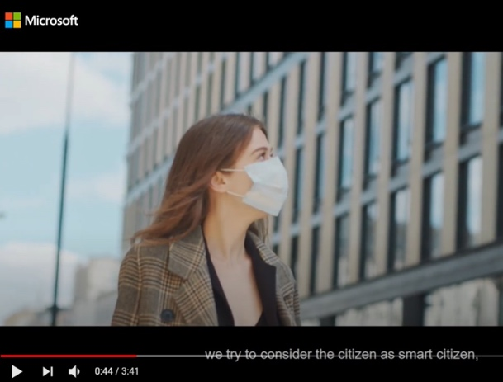
Figure 1 The screenshots here included show stills from videos where closed captions have been correctly included.
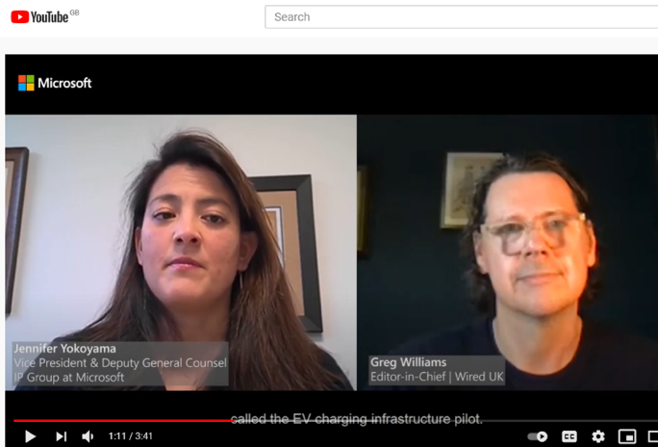
Figure 2 The screenshots here included show stills from videos where closed captions have been correctly included.

CASE STUDY: Kingsford “Preserve the Pit” Campaign
Closed-captioning placed on video content produced for Kingsford “Preserve the Pit.”
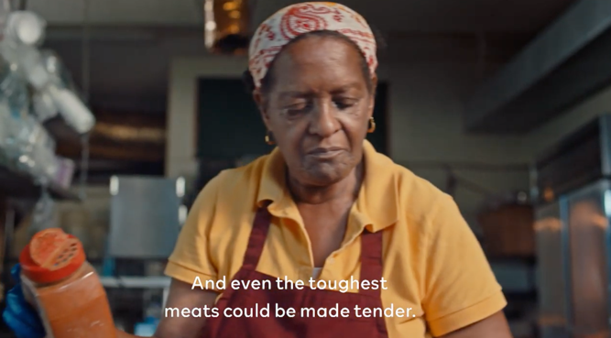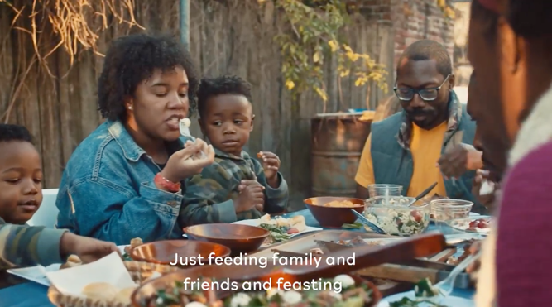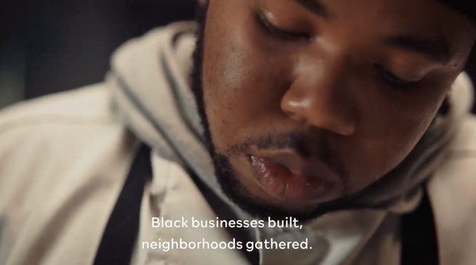

IMAGES

In this section, we’re focusing on images used to illustrate an idea or convey meaning on web pages, within social media posts, etc. Background or decorative graphical elements that are purely aesthetic can be marked as “decorative” within Alt Text (more on that later).
For all images, you should:
- Always include alternative text.
- Ensure that Alt Text is accurate, descriptive and succinct. Focus on describing the important message that an image is trying to convey.
- Avoid use of colour alone to convey important information.
- Avoid using important images as a background image, such as placing them behind text and other design elements. Doing so may mean that the images are not picked up or adequately described by screen readers – assistive technology used by people with visual impairments.
- Use strong contrast between text and background so people with low vision can see and use the content; use dark text on a white or off-white background, or white text on a dark background.
- Use images depicting individuals with disabilities interacting with products, services, and other people to confirm the reality that people with disabilities are individuals with capabilities, agency, and intersectional identities.
- Do not use non-disabled actors and models portraying disability as substitutes for people with disabilities. This harmful practice misrepresents the disabled community.
- Remember that a screenshot is also an image and should be treated in the same way as all other images with the use of Alt Text.

ADDING ALT TEXT TO IMAGES

Alternative text (or Alt Text) helps people who can’t see the screen understand what’s important in images and other visuals. Text should be accurate, descriptive and succinct. It should describe the important message that an image is trying to convey. It doesn’t need to be overly emotive.
To find images within a document that are missing Alt Text, use Microsoft’s Accessibility Checker tool which will direct you to the image and give you the option to add Alt Text. Background and decorative images can be marked as “decorative” within Alt Text – removing the need to add an Alt Text descriptor.

Here are examples of effective Alt Text:
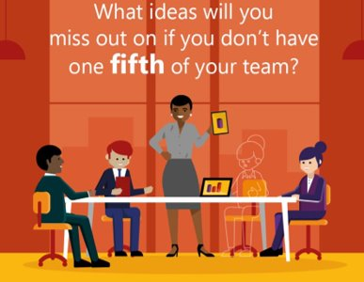
Good Alt Text example: Cartoon illustration of a diverse team meeting in a boardroom. Colleagues are seated around a table. Four are visible, but the fifth is only outlined to show the team is missing a core member.
Bad Alt Text example: A team meeting in an office.

Good Alt Text example: Photograph of a young Black woman smiling and waving at someone on her mobile phone screen. She has headphones on and is sat on a green chair.
Bad Alt Text example: A picture of a woman.

TEXT AND WRITTEN COPY

It might surprise you to learn that the average American reads at the 7th to 8th-grade level (or aged 12-14), and that 20 percent of the population reads at below a fifth-grade level. In the UK, as many as 7 million people have ‘very poor literacy skills’. To ensure the broadest accessibility across the cognitive spectrum, simplicity is paramount.
For all text and written copy, you should:
- Write concisely in plain language and the active voice.
- Avoid the use of abbreviations and jargon.
- Use high colour contrast text.
- Avoid more than two lines of centred text.
- Avoid more than one line of italics.
- Use appropriate disability-inclusive language, which affirms the human dignity of people with disabilities; the ADA National Network provides guidelines for writing about people with disabilities.
- Do not use disability-disparaging language as part of figurative language to convey negative meaning. For example, “blind” is often used as a synonym for ignorant or naïve.
- Consider creating an audio version of any news release to help those with visual impairments.
- Always use meaningful display names for hyperlinks.
- Limit the use of hashtags in social media posts and add them only to the end of a post.
- Capitalise the first letter of compound word hashtags
(e.g., #AccessibleByDesign).

A word about literacy
The need to promote literacy in communications is not unique to one industry, although the implications may be different across different fields.
- Health literacy is vital to making informed decisions for yourself and your family.
- Digital literacy impacts your ability to use innovative technologies to improve your work and personal life.
- Financial literacy impacts your economic well-being and that of your family, potentially for years to come.

Literacy extends to numeracy – the ability
to understand and work with numbers.
Mathematical equations within an image unknowingly deny access to people with Dyslexia and/or low vision, who rely on an optical character recognition (OCR) software, a screen reader, and/or Braille. To remedy this, use the computer programming language Mathematical Markup Language or Math ML, which maintains the format of mathematical expressions and enables people to consume content with adaptive technology.

PDFs

Microsoft’s Accessibility Checker (see page 30) is a great tool for flagging accessibility issues that need addressing in both Microsoft Word and PowerPoint.
PDFs, however, can cause issues for people with visual impairment as assistive readers can’t access the format, and the Accessibility Checker can’t be run over a PDF either.
If it is necessary to produce a document in PDF format, it is strongly recommended that you publish a companion version in another format as well, such as Word or Powerpoint. In addition, these short PDF training videos from Microsoft on YouTube share the steps to follow to make PDFs accessible; the University of Washington’s website offers an extensive guide on creating accessible PDF documents.

SOCIAL MEDIA CONTENT

Each social media platform has its own guidelines and standards for accessibility and inclusivity. Here we cover the basics for each. There are, however, some general dos and don’ts when it comes to making social media posts accessible to all that are relevant regardless of the platform.

DO | DO NOT
- Add or edit image Alt Text; check each platform for options/best practices.  - Caption videos; check each platform for options/best practices.  - Write accessible posts:  - When including a hyperlink, indicate whether it leads to an [AUDIO], [PIC], or [VIDEO] file.  - Use a URL shortener to minimise the number of characters in the hyperlink.  - Place any hashtags at the end of the post and capitalise the first letter of each word. | - Accept the machine-generated Alt Text without checking to see if you can provide more context for screen reader users.  - Use acronyms in posts.

INSTAGRAM

Top tips for making your posts and content accessible for Instagram:
- Automatic Alt Text uses object recognition technology to provide a visual description of photos for people with visual impairments. Users can hear descriptions of photos through a screen reader within Feed, Explore & Profile pages.
- Automatic Alt Text can be generic; it is generally better to replace with copy that provides more context for a photo description.
- Try to avoid Instagram Stories for important information.
- Add captions in Instagram Stories with enough information so the person doesn’t have to rely on audio.
- Limit emojis as screen readers read the title of each emoji.
Visit Instagram’s accessibility page to learn how they are supporting accessible content.
See the images below to see how easy it is to add Alt Text within Instagram.

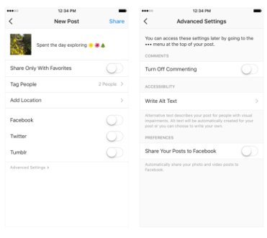
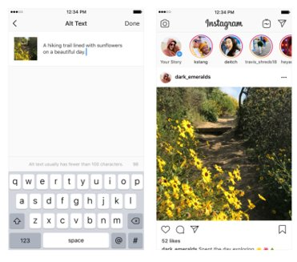

TWITTER

The top things to know when making your posts and content accessible for Twitter:
- When you Tweet photos using the Twitter app for iOS or Android, or on twitter.com, you have the option to add Alt Text so that content is accessible to more people, including those who are blind or have low vision.
- Be sure to turn on Alt Text for images within your Twitter settings. ​
- Twitter is currently working on a feature that will automatically add captions to video, it should be ready at some point this year.
- Limit emojis as screen readers read the title of each emoji.
Visit Twitter’s accessibility page which has easy-to-follow instructions on how to add image descriptions, how to add voice-over, and how to access and use screen readers for people with vision impairment.
The images show how easy it is to make posts accessible on Twitter.
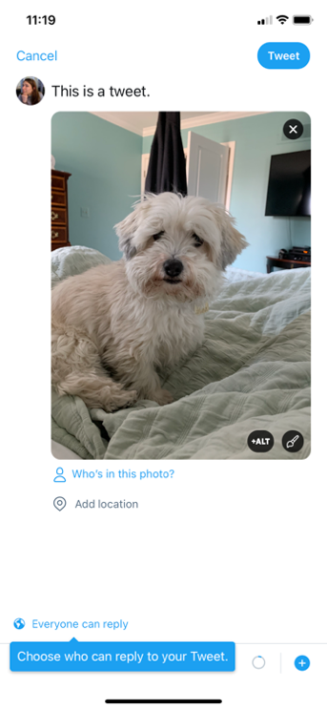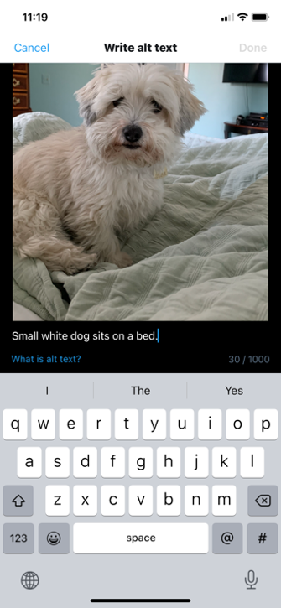

FACEBOOK

The top things to know when making your posts and content accessible for Facebook:
- You can add captions to a video to make it accessible to a broader audience using the SubRip (.srt) file format.
- If you choose to upload a .srt file, make sure your caption files are correctly named and formatted before you upload them.
- To add captions to an existing video on your Page, find the post on your Page’s timeline, click the top-right corner, select Edit Post and follow the steps.
Note: People who watch your Page’s video with sound turned OFF will automatically see captions. People who watch your video with sound turned ON will need to turn on captions to see them. The language captions appear in is determined by a user’s selected preferred language.
Click on Facebook’s accessibility page to learn more on how to make a post accessible on Facebook.

LINKEDIN

The top things to know when making your posts and content accessible for LinkedIn:
Add descriptive Alt Text to images in LinkedIn.
Make sure captions on any videos you include are burned into LinkedIn native video, visit Hootsuite for more information.
Click on LinkedIn’s accessibility page to learn more on how to make a post accessible on LinkedIn.

CASE STUDY: Shamrock Farms
Within weeks of committing to accessible communications, Current Global started employing best practices across client activations including:
Adding Alt Text into social content made for its client Shamrock Farms.

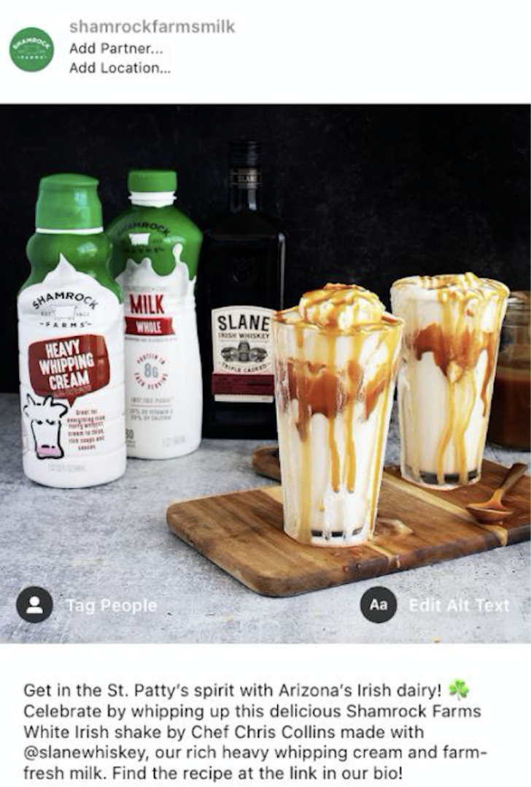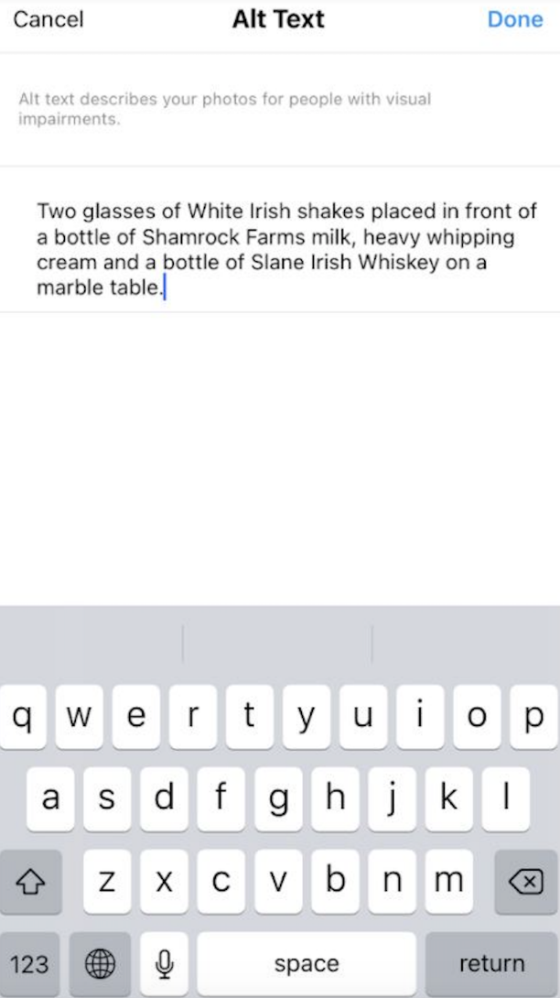

INFLUENCER CONTENT

As agency teams are not the only ones creating content for our clients these days, we should be sharing – and encouraging – the same use of guidelines and digital tools with influencers, asking them to be a part of the effort to make communications accessible to all.
Steps to employ:
- Include an ask to do their best to make communications accessible in briefs.
- Share these guidelines or other internal checklists along with the brief.
- Underline the ask and discuss any challenges during content production.
- Consider collaborating with influencers to add things like closed captions and audio transcripts to bigger projects.
- Work with internal teams to ensure people with disabilities are appropriately represented in partner recommendations.

PHYSICAL AND VIRTUAL EVENTS

Delivering events is commonplace in our industry – from town hall meetings for internal audiences to press briefings, trade shows, and large-scale gatherings for external audiences. While many venues and event planners are aware of making events accessible for attendees with mobility issues, there are several factors that should be considered to ensure your event’s communication meets the needs of everyone, whether that event is in-person or virtual. Do note, this space is quickly evolving but a few general guidelines include:
- Use the RSVP form to understand attendees needs.
- Communicate to attendees prior to the event about any lighting, fog machines or sounds that may be an issue.
- Include helpful accessibility information on the programme, homepage or running as a footer on your live events.
- Add closed-captions and audio descriptions to video presentations.
- Have a sign language interpreter for people with hearing impairment.
- Ensure speaker notes are reviewed for simple language and to catch acronyms or visuals that contain key information but don’t have written or verbal descriptions.
- Provide recordings or handouts of the presentations in case things may be missed in the live version.
- Ask the on-site event staff to help with details like writing utensils and paper for questions from people with speech disabilities or to deliver detailed verbal directions to the visually impaired.

HELPFUL TIPS AND TOOLS

Good news! Most of the tools we need to produce accessible communications are free and readily available.
Microsoft has a suite of tools within Office 365 that includes an embedded Accessibility Checker tool, and Microsoft Teams offers live captioning.
There are an abundance of how-to videos on YouTube to help make producing accessible content as straight forward as possible. Modern browsers all have the functionality to convert web text and images into speech. Every major social network has a range of accessibility tools. And the list goes on.

MICROSOFT ACCESSIBILITY CHECKER
Within each of the Office 365 products (Outlook, Word, PowerPoint, etc.) there is an Accessibility Checker. This tool automatically reviews your document for any areas that may create an accessibility problem.
HOW TO USE:
- Under the Review tab in your toolbar, select Check Accessibility (on the left-hand side).
- Click on each identified issue that gets flagged and the tool will take you to that location for resolution.
- Issues might include Alt Text missing from images, poor colour contrast with text on a page, titles missing from slides, inconsistent text running order on in a PowerPoint, etc.
- “Errors” that get identified as such should be addressed as they will cause problems to those with sight or hearing impairment.
- “Warnings” however are potential issues rather than must-fix errors.
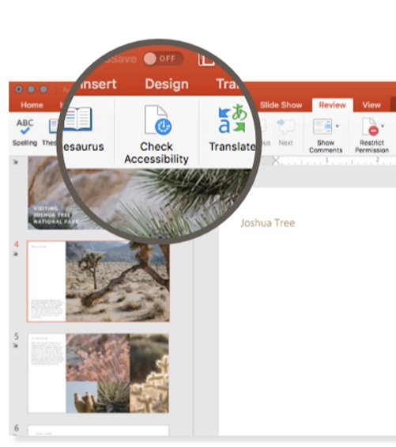

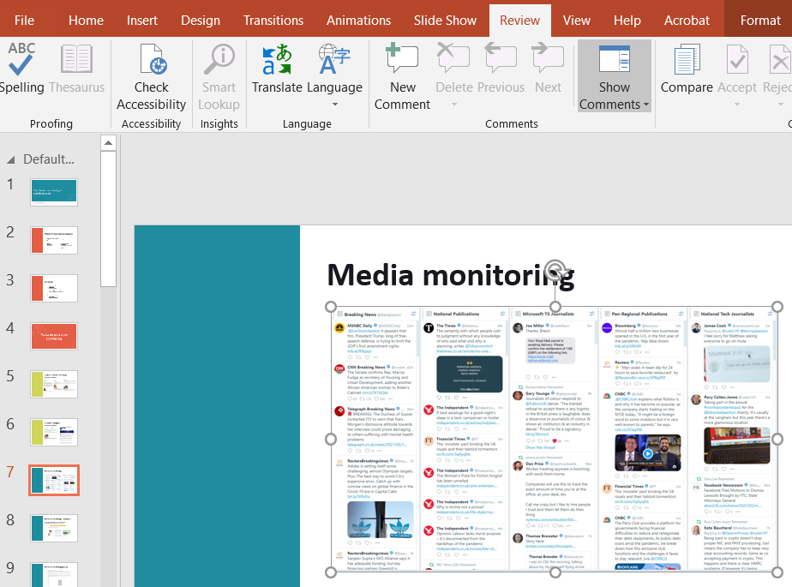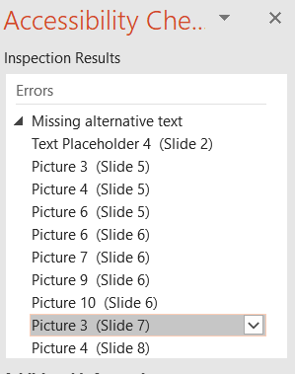

MICROSOFT COLOR CONTRAST ANALYZER

People with low vision often have difficulty reading text. The problems can be exacerbated if they also have a colour vision deficiency such as colour blindness that lowers the perceived contrast even further. Ensuring adequate contrast makes it easier for everyone – not just the visually impaired - to read text content.
Microsoft’s Color Contrast Analyzer is a feature in Accessibility Insights for Windows that helps developers and designers investigate contrast ratios. Colour contrast rules apply for video, motion graphics, graphics, and text overlay. Colour contrast must be 4.5:1 for small text (<18pt) or 3:1 for large/bold text.
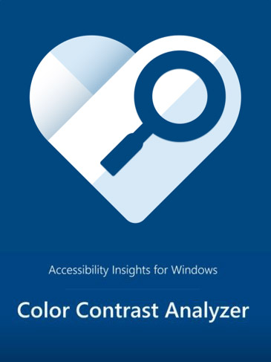

HOW TO USE:
- Visit Accessibility Insights Color Contrast to get started with this tool.
- Download the app on your desktop.
- Watch this short Accessibility Insights YouTube video to learn how to use the colour contrast analyser.
- Remember to check the Color Contrast Analyzer throughout the production of your content.

WINDOWS SCREEN READER

Windows 10 has a built-in, easy to use screen reader called Narrator for people who are visually impaired.
Narrator enables people who are blind or have a visual impairment to navigate websites, apps and Word documents.
This Microsoft Narrator YouTube video gives very simple instructions for getting started with Narrator, shortcuts to use and how to navigate through different websites and applications.

CASE STUDY: Microsoft “The Fifth” Campaign
Current Global supported client Microsoft with an EMEA-wide campaign called “The Fifth,” which highlighted the business value of embracing accessibility. To reach European business decision makers, the team created fully accessible assets that drew attention to Microsoft’s built-in accessibility solutions. A series of visuals explored how businesses that are not embracing accessibility are 'missing a fifth' of their opportunity, as well as The Worklife Hack series which highlighted Microsoft tools and features useful for all workers, including those with disabilities. Images were amplified across social channels and directed people to other content in the series, including an interactive quiz which further reinforced the importance of accessibility in the workplace.

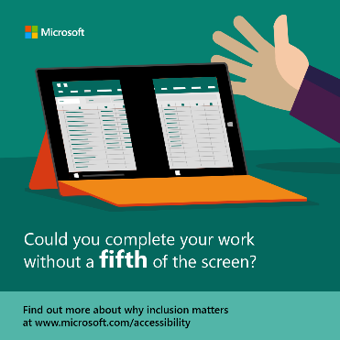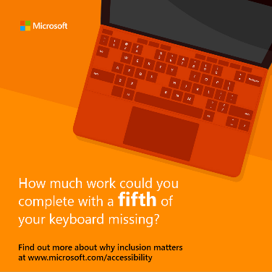

SECTION 4 – EMBEDDING ACCESSIBILITY INTO YOUR COMMS FUNCTION

BEST PRACTICE

While many tools to produce accessible content already exist, the key step-change really comes down to embedding accessibility standards and best practices in your overall approach to creating any kind of content. Clicking on the Accessibility Checker should become as routine as using spellcheck!

What does best practice look like?

Publish a manifesto
Once you’ve decided to commit to making communications accessible, write a manifesto that outlines what you’re doing and why you believe it to be important. Share it with colleagues, display it around your office, include it in your credentials or company brochure, post it on your website.
Here’s an example from Current Global:
My father is deaf. So is his twin brother, my uncle. Growing up it was always a challenge to communicate with them. But as a family, we always made the effort.
That’s what you do.
Sadly, it’s not always been my experience in professional communications. Every day content is published that’s inaccessible to many, campaigns are launched that aren’t designed to be inclusive of people of all abilities. But it doesn’t have to be that way.
Over a billion people – one in eight of the world’s population – have some form of disability. With an ageing population, more than two billion will need at least one assistive communication, memory or hearing aid in the next 10 years. That’s a significant audience to exclude by default or by design.
We have a moral duty to change this, and it makes obvious commercial sense for our clients too. So, we’re making a commitment as an agency.
When we say we’ll develop campaigns that engage everyone, we mean it.
When we make interactive online content, it won’t just be for some, but for all.
When we build brands, we’ll make sure they can reach every single person.
On behalf of our clients, every piece of communication we develop, curate and publish will meet the highest accessibility standards.
We’ll work to build the in-house capabilities of our clients to do the same.
And we’ll partner with professional bodies around the world to champion accessibility and promote industry best practice.
Things won’t change overnight, but if we make the effort, we hope others follow.
As passionate communicators, it’s what we do that matters.
George Coleman
Joint CEO, Current Global

Get your own house in order
Committing to accessible communications means that all external emails, documents, spreadsheets, presentations, visual content, etc. should be made accessible to all. Don’t forget though that this refers to the content and material you are producing internally as well as content for external audiences. Before you ‘go live’, make sure that your website has gone through all the necessary accessibility checks, and that credentials and templates that teams regularly use have been updated to meet the highest accessibility standards.
Regarding websites, there are several plug-ins available that identify on-going changes required to meet Web Content Accessibility Guidelines (WCAG 2.0). For more information, visit the W3C Guideline webpage.
Recognise that this is a continuous process, particularly to keep up with evolving accessibility standards and changing technologies.

Develop a communications plan
Let employees know what you’re committing to, why it matters and what your expectations of them are in delivering accessible communications. What internal communications channels can you use to spread the word? What training does your team need to understand the tools and requirements? Share regular reminders with staff to use the tools. Share case studies of work where it has been put into practice. Make accessibility training part of your on-boarding for all new employees.
Let clients or other stakeholders know what you are committing to, why it matters, how and when you plan to roll it out, any cost implications and what differences they are likely to see. For agencies, committing to accessible communications as part of your client service offer can often be accommodated within standard fee rates. Additional third-party costs can, of course, be flagged and passed on to clients.

Practice makes perfect
Get familiar with the tools included in these guidelines and start using them TODAY! Reference the Checklist at page 38 at the end of the document at the start of every project.

Plan ahead
Build in time to facilitate any extra steps required to make your content accessible. Involve creative, design and production teams early! Give them time to implement what’s required, whether that’s adding in closed captions for videos or reworking a previously used presentation to reflect the fact that the colour contrast needs to be improved.

CHECKLIST

Use this checklist to help ensure that your work is accessible by design. Share it with all team members, talk it through at the kick-off stage, and keep referencing it until accessibility becomes a natural part of everything you produce.

Project Kick Off
- Have I thought about all content that needs to be made accessible?
- Do I know how to ensure each element is made accessible?
- Have I alerted my creative, design and/or production team about what’s needed?
- Have I communicated why producing accessible content matters and (if I’m working agency-side) outlined any potential costs to be considered or approved by my client?

Midway Check In
- Have I checked that we are on course for all content to be accessible?
- Am I making necessary adjustments along the way as the project develops?
- Is the creative content being produced with accessibility addressed?
- Am I reviewing content to reduce jargon and improve comprehension?

Project Conclusion
- Have I delivered on our commitment to make content accessible to all?
- What lessons can I share for the next project?

